LockMe.com

Simplilearn |

Project Documentation

Ashwin Jiwane

2021

Table of Contents

Project Title: LockMe.com 1

Project Justification 2

The flow and features of the application: 2

Tech stack: 3

Architecture diagram / flow chart: 4

Project Users Stories: (Agile and Scrum): 4

Users stories 4

Project git Repositories: 5

How to run project: 5

Directory Structure / package: 6

# Project Title: LockMe.com

Date: 06-09-2021 Prepared By: Ashwin Jiwane

Project Justification:

Company Lockers Pvt. Ltd. hired you as a Full Stack Developer. They aim to digitize their products and chose LockedMe.com as their first project to start with. You’re asked to develop a prototype of the application. The prototype of the application will be then presented to the relevant stakeholders for the budget approval. Your manager has set up a meeting where you’re asked to present the following in the next 15 working days (3 weeks):

* Specification document - Product’s capabilities, appearance, and user interactions
* Number and duration of sprints required
* Setting up Git and GitHub account to store and track your enhancements of the prototype
* Java concepts being used in the project
* Data Structures where sorting and searching techniques are used.
* Generic features and three operations:
  + Retrieving the file names in an ascending order
  + Business-level operations:
    - Option to add a user specified file to the application
    - Option to delete a user specified file from the application
    - Option to search a user specified file from the application
    - Navigation option to close the current execution context and return to the main context
  + Option to close the application

The goal of the company is to deliver a high-end quality product as early as possible.

The flow and features of the application:

* Plan more than two sprints to complete the application
* Document the flow of the application and prepare a flow chart
* List the core concepts and algorithms being used to complete this application
* Code to display the welcome screen. It should display:
  + Application name and the developer details
  + The details of the user interface such as options displaying the user interaction information
  + Features to accept the user input to select one of the options listed
* The first option should return the current file names in ascending order. The root directory can be either empty or contain few files or folders in it
* The second option should return the details of the user interface such as options displaying the following:
  + Add a file to the existing directory list
    - You can ignore the case sensitivity of the file names
  + Delete a user specified file from the existing directory list
    - You can add the case sensitivity on the file name in order to ensure that the right file is deleted from the directory list
    - Return a message if FNF (File not found)
  + Search a user specified file from the main directory
    - You can add the case sensitivity on the file name to retrieve the correct file
    - Display the result upon successful operation
    - Display the result upon unsuccessful operation
  + Option to navigate back to the main context
* There should be a third option to close the application
* Implement the appropriate concepts such as exceptions, collections, and sorting techniques for source code optimization and increased performance

Tech stack:

* Java
* File Handling
* Data structure

## Architecture diagram / flow chart:

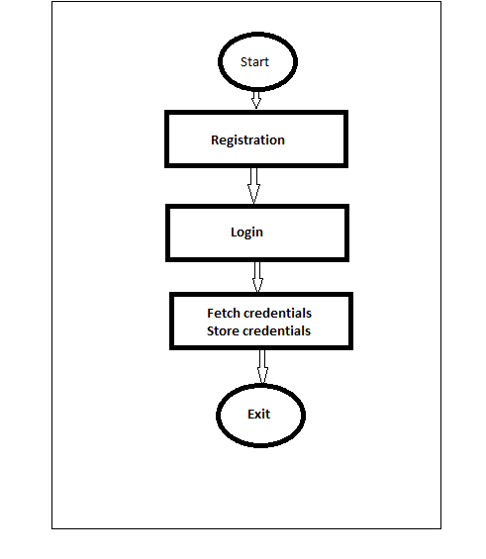

## Project Users Stories: (Agile and Scrum):

## Users stories

1. As a <role> i want <feature > so that <goal>

2. As a user i want lockme digital locker so that i can store my credentials.

3. As a user i want registration page so that i can access lockme app.

4. As a user i want login page to authenticate a user to access lockme app.

5. As a dev I want build registration page to enter user in system.

6. As a dev I want to build login page so that we can authenticate user.

7. As a dev create user interaction with console input.

**Sprint 1 (1week)**

1. As a <role> i want <feature > so that <goal>

2. As a user i want lockme digital locker so that i can store my credentials.

3. As a user i want registration page so that i can access lockme app.

**Sprint 2**

1. As a user i want login page to authenticate a user to access lockme app.

2. As a dev I want build registration page to enter user in system.

3. As a dev I want to build login page so that we can authenticate user.

**Sprint 3**

1. As a dev I want to build login page so that we can authenticate user.

2. As a dev create user interaction with console input.

## Project git Repositories:

1. link: <https://github.com/ashwin-aj/LockMe.git>

2. clone git: git clone <https://github.com/ashwin-aj/LockMe.git>

## How to run project:

4.1. clone project: clone git: git clone <https://github.com/ashwin-aj/LockMe.git>

4.2. open src/com/simplilearn/lockme/application/Application.java

-> right click -> run as java application

## Directory Structure / package:

